**PROJECT**

**LIBRARY MANAGEMENT SYSTEM**



NAME : Haseeb muhammad

Enrollment ID : 805

PROJECT :DATABASE

Department : Software Engineering

Semester : 4TH

Submitted To : Engr.zeeshan danish

**Step 1:Draw ERD for library management system**

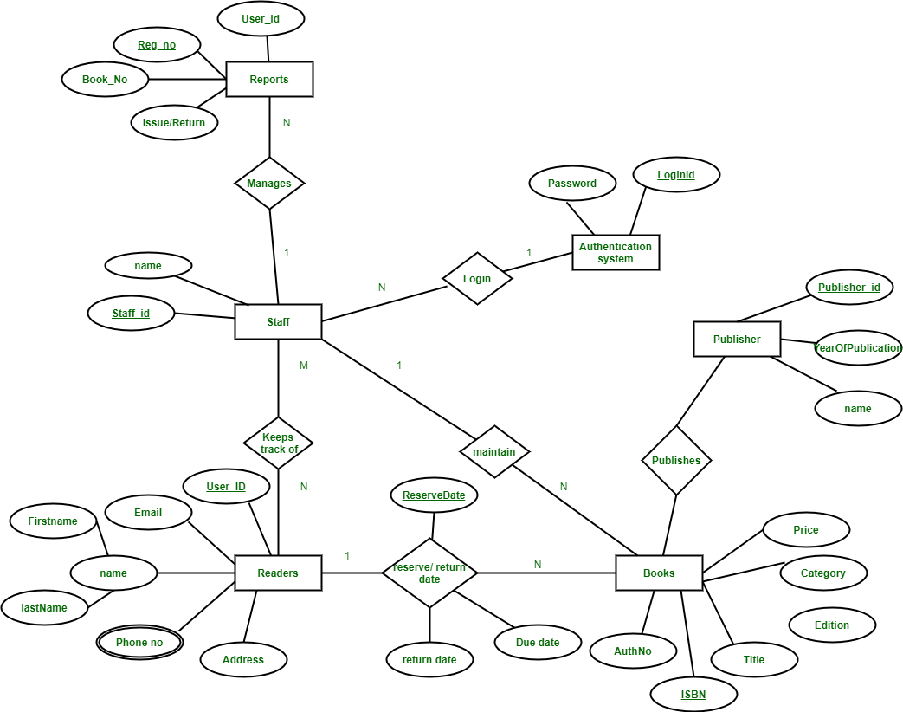

**Step 2:Entities and their Attributes –**

* **Book Entity : It has authno, isbn number, title, edition, category, price. ISBN is the Primary Key for Book Entity.**
* **Reader Entity : It has UserId, Email, address, phone no, name. Name is composite attribute of firstname and lastname. Phone no is multi valued attribute. UserId is the Primary Key for Readers entity.**
* **Publisher Entity : It has PublisherId, Year of publication, name. PublisherID is the Primary Key.**
* **Authentication System Entity : It has LoginId and password with LoginID as Primary Key.**
* **Reports Entity : It has UserId, Reg_no, Book_no, Issue/Return date. Reg_no is the Primary Key of reports entity.**
* **Staff Entity : It has name and staff_id with staff_id as Primary Key.**
* **Reserve/Return Relationship Set : It has three attributes: Reserve date, Due date, Return date.**

**Step 3:Relational mapping table:**

**Entity and attributes Primary key Forign key**

|  |  |  |
| --- | --- | --- |
| **Book Entity : It has authno,isbnnumber, title,edition, category, price.** | **ISBN** |  |
| * **Reader Entity : It has UserId, Email, address, phone no, name. Name is composite attribute of firstname and lastname.** | **UserId** |  |
| **Publisher Entity : It has PublisherId, Year of publication, name.**   * **Publisher Entity : It has PublisherId, Year of publication, name.** | **PUBLISHER-ID** |  |
| * **Authentication System Entity : It has LoginId and password** | **LoginID** |  |
| * **Reports Entity : It has UserId, Reg_no, Book_no, Issue/Return date.** | **Reg_no** |  |
| * **Staff Entity : It has name and staFF** | **staff_id** |  |
| * **Reserve/Return Relationship Set(Reserve date, Due date, Return date.** | **Reserve_ID** |  |

**Step 4: SQL FOR LIBRARY MANAGEMENT SYSTEM.**

**CREATION**

SQL> create table lib ( bookname varchar(15),author varchar(15), publicationvarchar(10), noofcopies number);

Table created.

SQL> create table student ( rollno number,  name varchar(20), no_card number  );

Table created.

SQL> create table books ( bookno number, bookname varchar(15),

available varchar(10),subscribed_to number );

Table created.

SQL> create table subscription ( bookno number, rollno number, do_sub date,

do_return date,  fineamount number,status varchar(10) );

Table created.SQL> desc lib;

 Name                                      Null?    Type

 ----------------------------------------- -------- ----------------------------

 BOOKNAME                                           VARCHAR2(15)

 AUTHOR                                             VARCHAR2(15)

 PUBLICATION                                        VARCHAR2(10)

 NOOFCOPIES                                         NUMBER

SQL> desc student;

 Name                                      Null?    Type

 ----------------------------------------- -------- ----------------------------

 ROLLNO                                             NUMBER

 NAME                                               VARCHAR2(20)

 NO_CARD                                            NUMBER

SQL> desc books;

 Name                                      Null?    Type

 ----------------------------------------- -------- ----------------------------

 BOOKNO                                             NUMBER

 BOOKNAME                                           VARCHAR2(15)

 AVAILABLE                                          VARCHAR2(10)

 SUBSCRIBED_TO                                      NUMBER

SQL> desc subscription;

 Name                                      Null?    Type

 ----------------------------------------- -------- ----------------------------

 BOOKNO                                             NUMBER

 ROLLNO                                             NUMBER

 DO_SUB                                             DATE

 DO_RETURN                                          DATE

 FINEAMOUNT                                         NUMBER

 STATUS                                             VARCHAR2(10)

**INSERTION**

SQL> begin

  2      insert into student values(&rollno,'&name',2);

  3      end;

  4      /

Enter value for rollno: 5058

Enter value for name: pavi

old   2:     insert into student values(&rollno,'&name',2);

new   2:     insert into student values(5058,'pavi',2);

PL/SQL procedure successfully completed.

SQL> /

Enter value for rollno: 5100

Enter value for name: vidhya

old   2:     insert into student values(&rollno,'&name',2);

new   2:     insert into student values(5100,'vidhya',2);

PL/SQL procedure successfully completed.

SQL> /

Enter value for rollno: 5097

Enter value for name: anitha

old   2:     insert into student values(&rollno,'&name',2);

new   2:     insert into student values(5097,'anitha',2);

PL/SQL procedure successfully completed.

SQL> /

Enter value for rollno: 5066

Enter value for name: hari

old   2:     insert into student values(&rollno,'&name',2);

new   2:     insert into student values(5066,'hari',2);

PL/SQL procedure successfully completed.

SQL> /

Enter value for rollno: 5056

Enter value for name: suresh

old   2:     insert into student values(&rollno,'&name',2);

new   2:     insert into student values(5056,'suresh',2);

PL/SQL procedure successfully completed.

SQL> ed ins;

bookno number;

bname varchar(15);

noc number;

noc1 number;

author varchar(15);

publication varchar(10);

nobooks number;

lib_rec lib%rowtype;

begin

bookno:=&bookno;

bname:='&bookname';

author:='&author';

publication:='&publication';

noc:=&noofcopies;

noc1:=noc;

select count(*) into nobooks from lib where bookname=bname;

if nobooks=0 then

insert into lib values(bname,author,publication,noc);

else

update lib set noofcopies=noofcopies+noc where bookname=bname;

end if;

while noc!=0

loop

insert into books values(bookno,bname,'yes',0);

noc:=noc-1;

bookno:=bookno+1;

end loop;

end;

SQL> @ ins;

 30  /

Enter value for bookno: 23

old  11: bookno:=&bookno;

new  11: bookno:=23;

Enter value for bookname: cn

old  12: bname:='&bookname';

new  12: bname:='cn';

Enter value for author: forozan

old  13: author:='&author';

new  13: author:='forozan';

Enter value for publication: tata

old  14: publication:='&publication';

new  14: publication:='tata';

Enter value for noofcopies: 4

old  15: noc:=&noofcopies;

new  15: noc:=4;

PL/SQL procedure successfully completed.

SQL> /

Enter value for bookno: 28

old  11: bookno:=&bookno;

new  11: bookno:=28;

Enter value for bookname: ooad

old  12: bname:='&bookname';

new  12: bname:='ooad';

Enter value for author: scilber

old  13: author:='&author';

new  13: author:='scilber';

Enter value for publication: tata

old  14: publication:='&publication';

new  14: publication:='tata';

Enter value for noofcopies: 4

old  15: noc:=&noofcopies;

new  15: noc:=4;

PL/SQL procedure successfully completed.

SQL> /

Enter value for bookno: 32

old  11: bookno:=&bookno;

new  11: bookno:=32;

Enter value for bookname: dbms

old  12: bname:='&bookname';

new  12: bname:='dbms';

Enter value for author: elmasri

old  13: author:='&author';

new  13: author:='elmasri';

Enter value for publication: tata

old  14: publication:='&publication';

new  14: publication:='tata';

Enter value for noofcopies: 4

old  15: noc:=&noofcopies;

new  15: noc:=4;

PL/SQL procedure successfully completed.

**END**